**ICP 1**

**Name: Gowtham Sai Reddy Maddireddy**

**Student Id: 700759075**

**GitHub Link:** [Gowthamsai08/ICP-1](https://github.com/Gowthamsai08/ICP-1)

**Video Link:** [**https://drive.google.com/file/d/1QKDLjjdW49ofL45K26RO8jRXPX3J77rQ/view?usp=drive_link**](https://drive.google.com/file/d/1QKDLjjdW49ofL45K26RO8jRXPX3J77rQ/view?usp=drive_link)

1. Write a program that takes two strings from the user: first_name, last_name. Pass these variables to fullname function that should return the (full name).

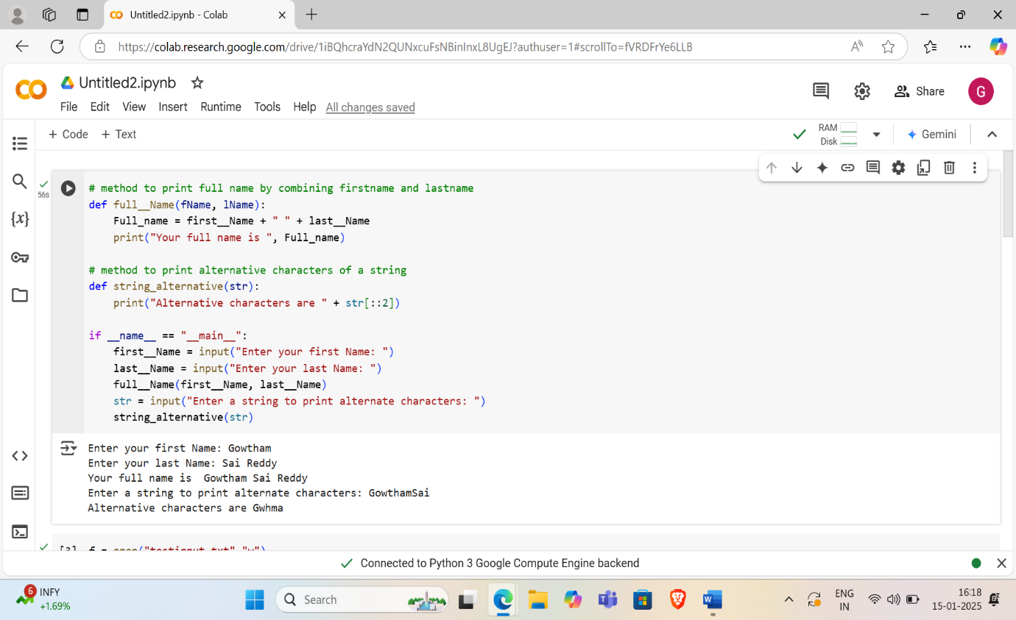

1. Write a python program to find the wordcount in a file (input.txt) for each line and then print the output. o Finally store the output in output.txt file.

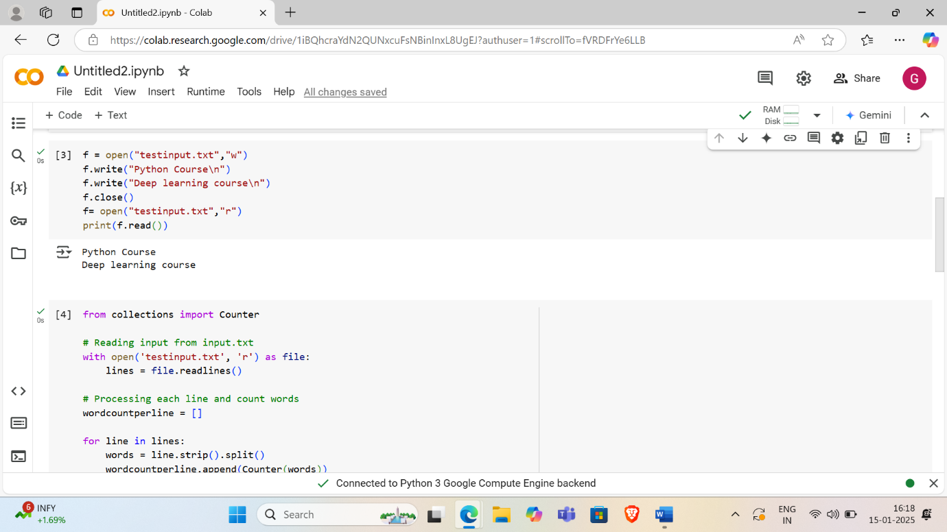

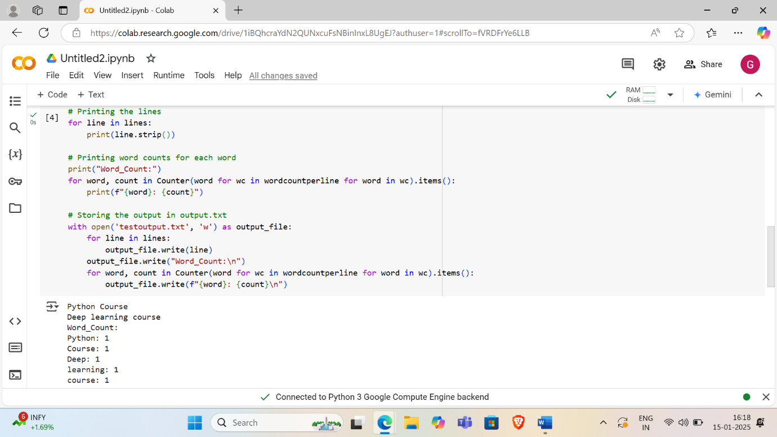

1. Write a program, which reads heights (inches.) of customers into a list and convert these heights to centimeters in a separate list using:

